THE IMPACT OF COVID-19 ON INTERNATIONAL TRAVEL SERVICES

The Name Of The Class (Course)
Professor
University
City, State
Date

THE IMPACT OF COVID-19 ON INTERNATIONAL TRAVEL SERVICES
Since the outbreak of the coronavirus disease of 2019, more than two million people have lost their lives due to the pandemic, and the global economy is also staggering. Thousands of jobs have been lost and millions of stocks at risk. The pandemic affects the societies and economies of nations in Africa regarding the arrival of international passengers arrival, dependence, openness upon international trade. The pandemic is generally a health crisis but has massive ramifications to many global order states. Currently, international trade is hard-hit by the disease. Merchandise trade continues to record a decline in the second quarter of 2020, falling to 14.3% compared to other years. Despite the partial rebound of lockdowns, the total global merchandise trade for the last year is still meager. Such changes to international trading have severe consequences on mental and physical health, affecting the supply of necessary material, food security, government income, and nutrition ("impact of COVID-19 international travel restrictions on services-trade costs").
The café industry is no exception to the challenges mentioned earlier. The hospitality industry is one of the worst hit by the pandemic. Business pauses, alterations, and lockdowns to the way people pay for services and goods have had repercussions on restaurants and cafes.TCLF product sales have also suffered the impacts of covid 19.more clothing shops are forced to close due to the government restrictions and as clients are strict about staying at home. The European Union, the apparel and textile sector faced a potential 50% drop in sales. Leading brands have been forced to close in major countries and have also met a massive reduction in sales globally. The sales of Adidas in China fell by 75% between the first two months of 2020.universal stock markets have reacted positively to the pandemic in the face of recession. Major brands such as Inditex, Gap, and Adidas have suffered dwindling stock for most of 2020.
Since the outbreak's peak, shortages of inputs and raw materials are the primary concern for footwear and garment producers. Such shortages have caused disruptions to manufacturing across the globe. Since there is a shift in the epicenter, factories in many nations have been forced to close. The maquila industry in Mexico stopped production following the federal order to complete the non-essential economic activities, yet the sector employs more than 2 million workers. Although garment factories are slowly resuming operations, most companies face problems to ramping up production, for instance, the continuous shortfall of raw material and high cost of Labour. Although there is an improvement in supply from china, there is a decrease in demand from major countries such as central America. Falling sales and production have a significant effect on workers in terms of working conditions and employment. More than 200 factories in Cambodia have either reduced or suspended production, and at least 4000 workers have lost their jobs. In Myanmar, the lack of raw material has led to more than ten factories and the loss of more than 5000 jobs.
Nightclubs and bars have not fared well in the pandemic due to social distancing. As nations globally passed lockdown measures, nightclubs and bars were among the first businesses ordered to close and are the most likely to the last firms to reopen. Since such companies are designed for social interaction, it may be challenging to reopen them without strict measures (Matzinger,P.2020 ). For example, in Atlantic areas, all the provinces closed the bars by the third week of March, restricting sales to drive-thru and take-out. More than 42 percent bar establishment was closed in May compared to 57 percent in April. Such provinces recorded a fall in bar sales of up to 42 percent in May last year. This statement implies that the Atlantic provinces lost almost 125 million dollars in revenues (Zhao,Y.2020).
Leisure centers have been badly hit by the pandemic and possess a hard path to recovery. Consumers are still cautious since their confidence to go back to leisure centers is still below average. Recent research suggests that only 27 percent of clients are confident of returning to entertainment and leisure centers. Confidence is higher in Australia, France, and China confidence percentage of 33,35 and 38 percent, respectively. Due to the strict covid -19 restrictions, leisure centers and gyms are temporarily closed to reduce the spread of the pandemic (Zheng, S.2020).
Nevertheless, the pandemic has on leisure providers remains critical as a result of limited cash reserves and loss of income. in fact, most of the leisure providers may be unable to receive emergency support funding. Since the councils eligible to offering support are in a very challenging position, they have limited ability and resources to provide financial support .the lockdown and strict measures have forced many to choose alternative activities such as walking and running to keep active. Most home workout equipment has increased during the lockdown period, with cardio machines, kettlebells, and weight machines becoming very expensive. As a result, most trainers have shifted to online training with live classes on zoom and Instagram. The providers have also turned to create a home workout program for their specific clients. Such types of personal training programs appeal to both the existing and attract clients from different parts of the world. Leisure centers have experienced the most challenging times during this period in terms of generating any form of income. in most cases, clients' payments have been frozen, and personal trainer fees have also been cut off.
The global online food delivery services market has recorded growth from $115.07 billion in 2020 to $126.91 billion at a CAGR of10.3 percent. The change results from the resumption of companies' operations and the adaptation of new business ways. The increase in smartphone use has also boosted food delivery services globally. The global food and beverages e-commerce user reached 1.5 billion by the end of 2019. zomato, an Indian food delivery platform, has also recorded a customer increase in terms of orders requested by clients ("COVID-19 impacts on agri-food value chains").

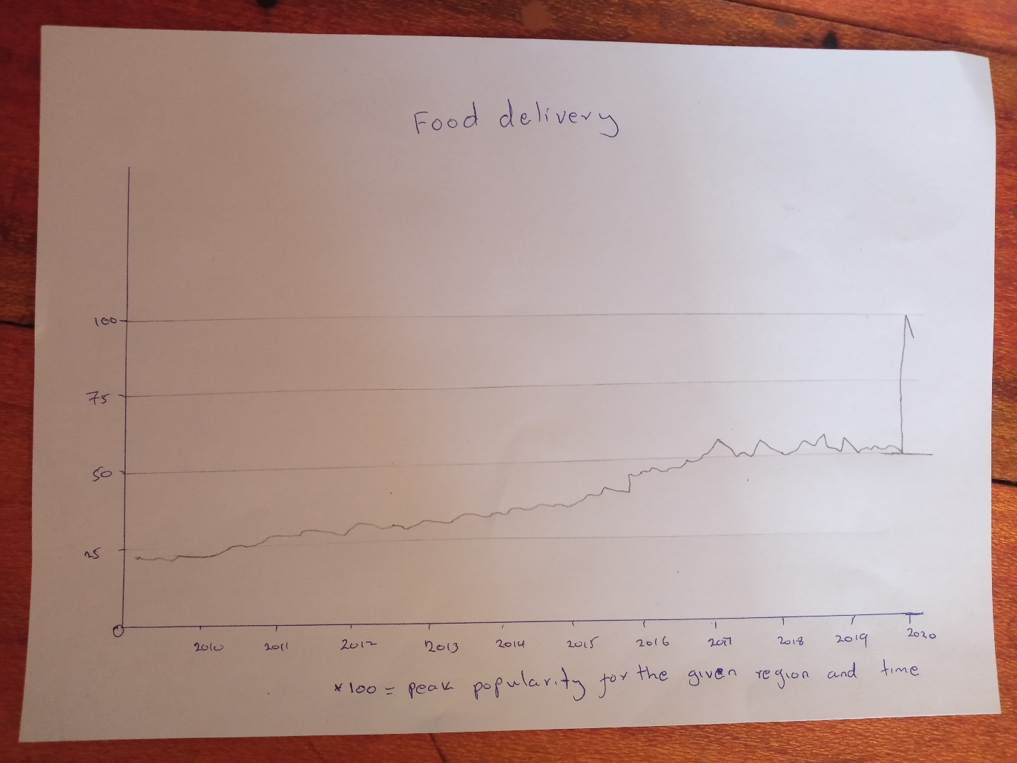

References

"COVID-19 impacts on agri-food value chains." 2021. doi:10.4060/cb3089en.

"The impact of COVID-19 international travel restrictions on services-trade costs." OECD Trade Policy Papers, 2020. doi:10.1787/e443fc6b-en.

Matzinger, P., and J. Skinner. "Strong impact of closing schools, closing bars and wearing masks during the COVID-19 pandemic: Results from a simple and revealing analysis." 2020. doi:10.1101/2020.09.26.20202457.

Zhao, Y., and F. Bacao. "undefined." International Journal of Hospitality Management 91 (2020), 102683. doi:10.1016/j.ijhm.2020.102683.

Zheng, S. "Social distancing and leisure activities after COVID-19." AEA Randomized Controlled Trials, 2020. doi:10.1257/rct.5644-1.0.

